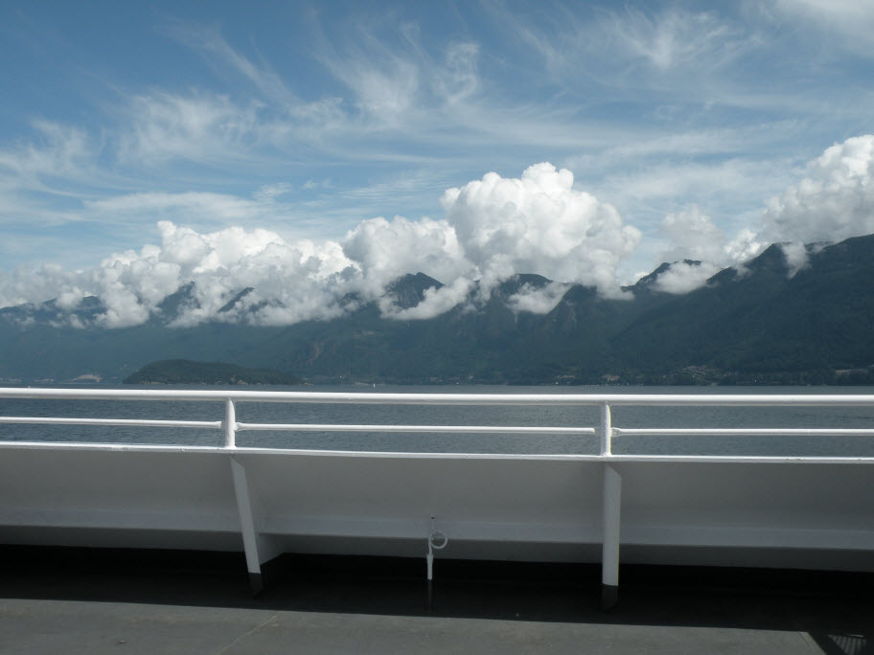
On The Ferry To Fir Island
eco-reserve conference proposal
submitted by island nature club

zainab

Table of Contents
Introduction 2
Facilities 2
Accommodations 2
Additional Accommodations 3
Meeting Venues 3
Audio/Visual Equipment and Internet 4
Catering/Dining Facilities 4
Access and Travel 4
Special Events 4
Opening Reception 4
Activities 5
Conclusion 5

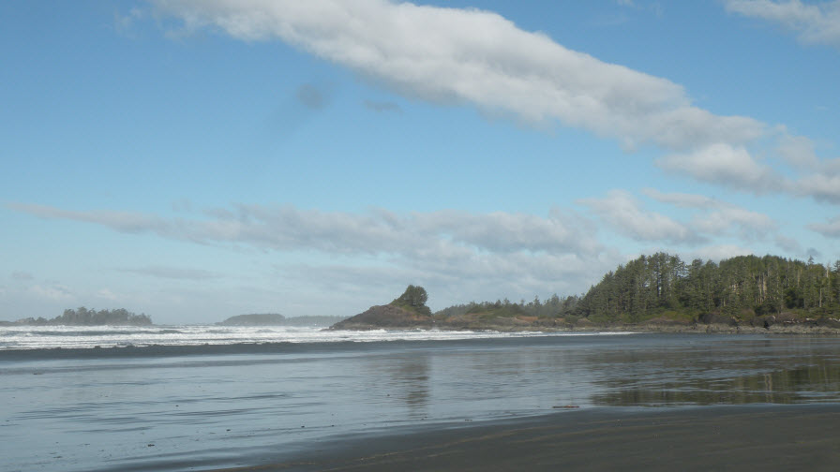
Introduction
Figure 2: View From Fir Island Lodge
The Fir Island Nature Club would be delighted to host the Eco-Reserve Conference on beautiful Fir Island, just a twenty minute ferry ride from Brentwood Bay, just outside of Victoria, BC. Fir Island is well known for its world class nature preserve (the Fir Island Reserve), glorious beaches, forest trails, and friendly community. The Fir Island Nature Club believes that Fir Island would be a magical place for the Eco-Reserve conference.
Fir Island offers a unique experience to delegates that is very much in keeping with Eco-Reserve’s mandate of promoting and celebrating the natural environment in British Columbia. The principal venue we propose—The Fir Island Lodge—is a rustic getaway right on the waterfront. The Lodge has recently been renovated to a high standard of comfort while still retaining a lovely “summer camp” feel. Delegates can stroll to the beach, soak in the hot tub, take a walk into quaint Welcome Cove where the ferry docks, and hike the numerous woodland trails.
Following are details related to the Fir Island Nature Club’s bid to host the Eco-Reserve conference.

Facilities

Accommodations
Fir Island Lodge would be the principal venue for the conference with additional venues used as needed to accommodate delegates. The Fir Island Lodge accommodates up to 50 people in 25 guest rooms. All the guest rooms can accommodate up to two people. Costs are as follows:
22 rooms with twin or double beds $129
1 Junior Suite with one queen bed $159
1 Superior Suite with 1 queen bed $189
1 Cottage with 1 king bed and kitchen $209
When a majority of the rooms in the Fir Island Lodge are booked, the meeting rooms and other facilities are included at no extra cost. The Lodge contains the following venues for meetings:
- One very large room that can accommodate up to 140 people and can be divided into two rooms for breakout sessions
- One suite that can accommodate 20 people
- One board room that can accommodate 20 people

Additional Accommodations
In addition to the accommodation offered at Fir Island Lodge, delegates can choose from the bed and breakfast establishments listed below, each of which is within walking distance of the Fir Island Lodge.
Accommodation | Rooms | Cost | Contact
Evergreen Bed and Breakfast | 5 | $125 - $235 | 250-555-1266
Heron Point Guest House | 4 | $145-$235 | 250-555-5789
Laurel Hideaway | 4 | $150 | 250-555-8823
Lighthouse Point Bed and Breakfast | 4 | $210 - $340 | 250-555-1276
Pacific Sands Bed and Breakfast | 4 | $135 | 250-555-3466
Seastrand House | 4 | $125 | 250-555-9340
Sea view Bed and Breakfast | 3 | $125 | 250-555-7899
Sunset Bed and Breakfast | 4 | $125 - $165 | 250-555-1800
Waves Hideaway | 4 | $190 | 250-555-8723

Meeting Venues
As noted above, the principal meeting venue would be at the Fir Island Lodge which can accommodate up to four breakout sessions—large room divided into two that can accommodate up to 70 people each and two rooms that can accommodate 20 people each. In addition, Seastrand House (five minute walk) can accommodate a meeting of up to 30 people and the Fir Island Community Hall (a 15 minute walk or short bus ride from the Lodge) can accommodate up to 75 people.
The venues available on Fir Island are not conventional hotel meeting rooms. Delegates may need to move around to different locations. However, we feel this activity is part of the charm of coming to Fir Island for the Eco-Reserve conference. A shuttle bus will be available as needed.

Audio/Visual Equipment and Internet
The Fir Island Lodge has free Wi-Fi throughout the facility. In addition, the Lodge has two 50″ TV screens, a large pull down screen and a sound system. The Fir Island Nature Club can provide two projectors at a nominal additional charge.

Catering/Dining Facilities
The Fir Island Lodge can provide catering for the entire conference—up to 140 people seated at tables. We anticipate the following schedule for food service:
- Friday Reception: Reception hosted by the Fir Island Nature Club held at the Fir Island Community Hall—a stunning venue overlooking the Pacific Ocean. The reception will include a cash bar, hors d’oeuvres, and musical entertainment. Following the reception, delegates who are staying on Fir Island can either go to one of the five restaurants on the Island or arrangements can be made for a buffet dinner at Fir Island Lodge.
- Saturday Breakfast: Buffet breakfast at the Lodge
- Saturday Lunch: Buffet lunch at the Lodge
- Saturday Banquet: Banquet at the Lodge
In addition, the Lodge can provide snacks during breaks. Delegates who go to other venues for breakout sessions will also be provided with snacks arranged through one of the local cafes.

Access and Travel
Getting to Fir Island is half the attraction of any visit to the Island. The Queen of Georgia from Brentwood Bay outside Victoria runs almost hourly beginning at 5:00 am with the last ferry leaving Fir Island at 10 pm. The ride is just twenty minutes past some of the most breathtaking marine scenery in western Canada. Delegates who live in Victoria can easily commute to Fir Island for the conference events. A walk-on passenger pays $9.10 and a passenger with a vehicle pays $32.65. We recommend that delegates walk onto the ferry instead of bringing cars. Parking is limited near the Lodge and in Welcome Cove. The Fir Island Nature Club can arrange to pick up people who need assistance. The Lodge also provides a shuttle service.

Special Events

Opening Reception
The Fir Island Nature Club proposes a cocktail reception with cash bar and hors d’ouevres at the stunning new Fir Island Community Hall. The Hall overlooks a stunning view of the southern Gulf Islands and the Olympic Mountains in Washington State. The Hall can accommodate up to 110 people for a reception. A local band will perform.

Activities
The Fir Island Nature Club will also organize additional activities, depending on the preferences of the delegates.

Conclusion
Fir Island is a special place. The people who live here love to share the island with visitors. Every weekend, notices for nature walks, concerts, art openings, garden walks, plant sales, and other community events crowd the bulletin boards. At the same time, Fir Island is a great place to just relax and enjoy the view. Delegates looking for a lively night life won’t find it on Fir Island. What they will find is a level of tranquility and quiet that has become all too rare in our modern lives.
The Fir Island Nature Club welcomes the opportunity to host delegates from all over British Columbia. Delegates will experience the unique charm that has made Fir Island a magnet for environmentalists and nature lovers from all over the world while also enjoying the opportunity to network with fellow delegates in surroundings that are truly spectacular – rain or shine!

